Blake Rude

CS 360

Final Project Demo Outline

8 May 2020

Project Demo

This outline will explain what the demo is capable of, as well as directions on how to run.

**Getting Started:**

1. Clone my [GitHub Repository](https://github.com/BlakeRude/360RelationalAlgebra).
2. Make sure [MySQL](https://dev.mysql.com/downloads/mysql/) is installed on your computer.
3. On MySQL, set up a local instance with username ‘root’, and password ‘Password1!’.
4. Download a version of [MAMP](https://www.mamp.info/en/windows/), set your APACHE ports to 8889, and MySQL to port 3307. 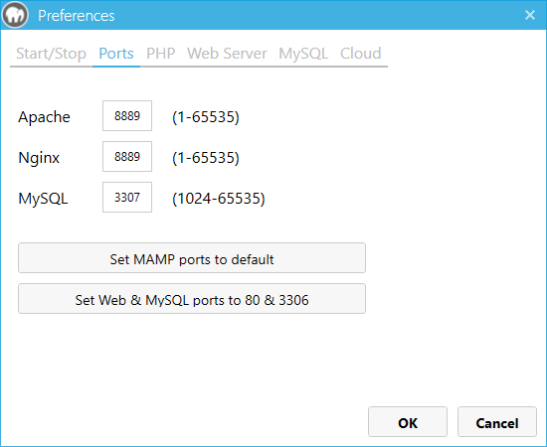
5. In MAMP, go to preferences>web server>directory root, and place the directory of my project there. 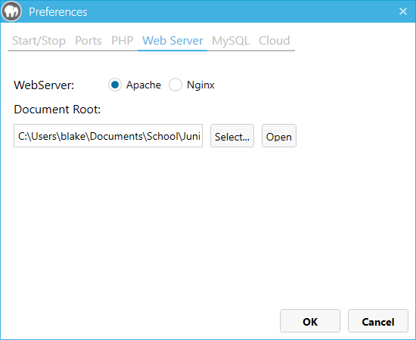
6. Go into [Chrome](https://www.google.com/chrome/), [Firefox](https://www.mozilla.org/en-US/firefox/new/), or [Internet Explorer](https://www.microsoft.com/en-us/download/internet-explorer.aspx) and in the address bar type localhost:8889, and then click on sandbox.php. 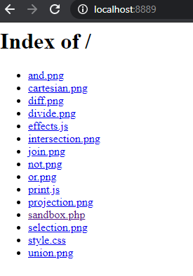

**Once working:**

Once the webserver is running and sandbox.php is open on your browser, you may now see the functionality. Firstly, SQL commands work by inputting into the input section and pressing submit, but you may also click the buttons to insert relational algebra symbols to use relational algebra instead of SQL. Unfortunately, due to time crunch, the pandemic, and my confusion, I do not have Relational Algebra submission functionality. Pressing submit with any relational algebra queries will not return anything. Also, due to a bug, the page must be refreshed with F5 key, or the reset page button, to be able to input relational algebra symbols.